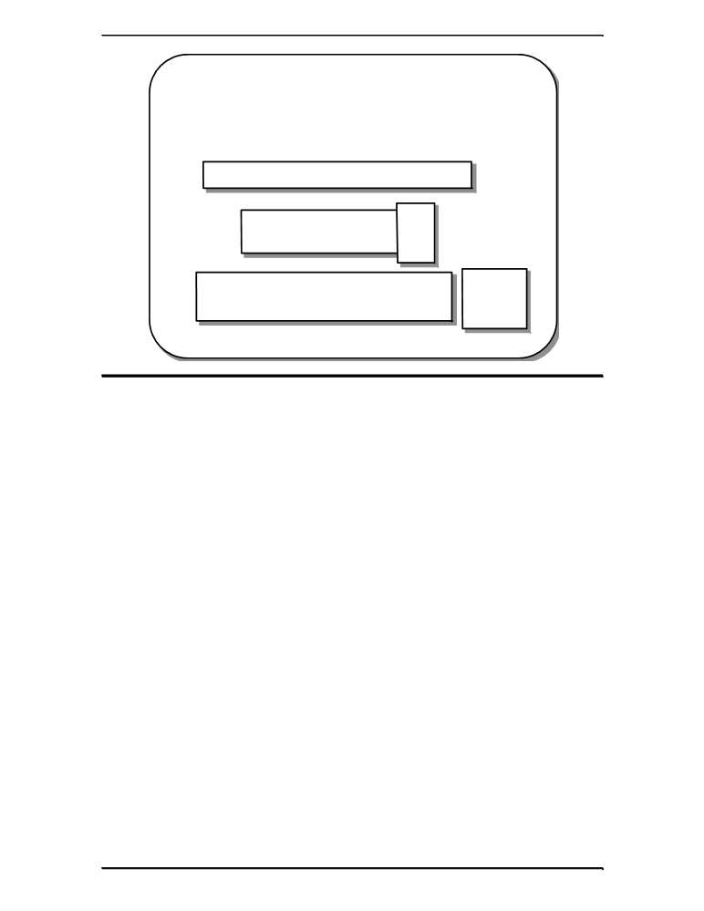

for Loop

▪ for encapsulates the essential elements of a
loop into one statement

for(initial-part; while-condition; update-part)
body;

int j;
for(j = 5; j > 0; j--)
printf("j = %i\n", j);

j = 5
j = 4
j = 3
j = 2
j = 1

for(j = 5; j > 0; j--) { j = 5 odd

printf("j = %i ", j); j = 4 even

printf("%s\n", ((j%2)==0)?"even":"odd"); j = 3 odd

} j = 2 even
j = 1 odd

for Loop

The for loop is syntactically the most complicated of C’s 3 loops. Essentially
though, it is similar to the while loop, it even has a while type condition. The C
oop is one of the most concise expressions of a loop available in any
language. It brings together the starting conditions, the loop condition and all
update statements that must be completed before the loop can be executed
again.

for And while The construct:
Compared
for(initial-part; while-condition; update-part)
body;

is equivalent to:
initial-part;
while(while-condition) {
body;
update-part;

